Practical no. 4
Name :- Danish Altaf Solkar Enrolment no. :-24111590805
Class :- CO3K – B Subject :- DMS
Aim:- Execute DML commands to manage database using SQL

QUERY :- CREATE TABLE Empl(Empno NUMBER(3)Primary key,Ename VARCHAR(30),City VARCHAR(20),Salary NUMBER(6));
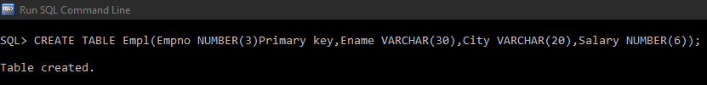

QUERY :- INSERT INTO empl VALUES(1,'Danish','Neral',10000); 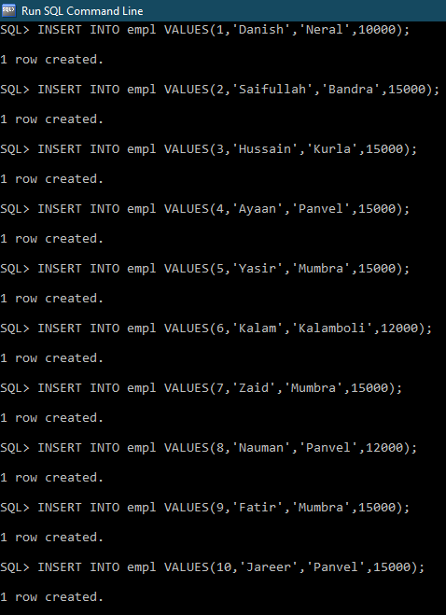
QUERY :- desc Empl;
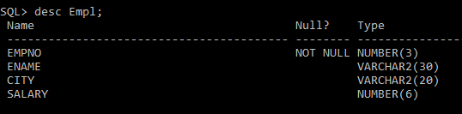

QUERY :- UPDATE Empl SET City = 'Taloja' WHERE empno = 7;
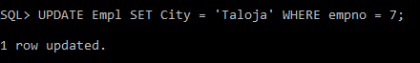

QUERY :- UPDATE Empl SET Salary = 10000 WHERE ename = 'Kalam';
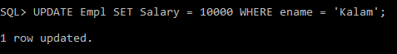

QUERY :- SELECT * FROM Empl ORDER BY salary;
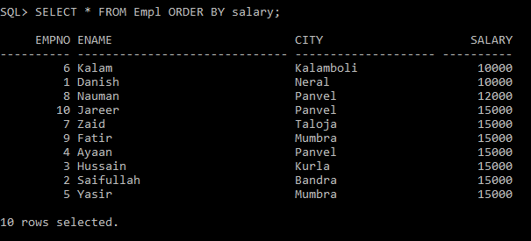

QUERY :- SELECT * FROM Empl ORDER BY ename;
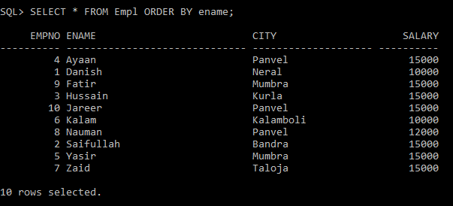

QUERY :- SELECT * FROM Empl ORDER BY ename DESC;
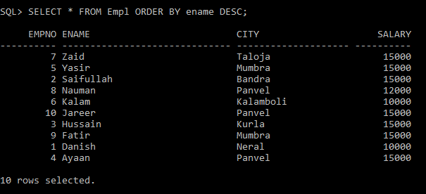
QUERY :- DELETE FROM Empl WHERE empno = 7; 